## Project title:Bitcoin Historical price Regression Analysis

## College: BMSIT

## Email: [pmprasunn457@gmail.com](mailto:pmprasunn457@gmail.com)

## Introduction:

A cryptocurrency (or crypto currency) is a digital asset designed to work as a medium of exchange that uses cryptography to secure its transactions, to control the creation of additional units, and to verify the transfer of assets. Cryptocurrencies are classified as a subset of digital currencies and are also classified as a subset of alternative currencies and virtual currencies. Cryptocurrencies use decentralized control as opposed to centralized electronic money and central banking systems. The decentralized control of each cryptocurrency works through a blockchain, which is a public transaction database, functioning as a distributed ledger.

## BITCOIN:

Bittcoin is a cryptocurrency and worldwide payment system. It is the first decentralized digital currency, as the system works without a central bank or single administrator. The network is peer-to-peer and transactions take place between users directly, without an intermediary. These transactions are verified by network nodes through the use of cryptography and recorded in a public distributed ledger called a blockchain. Bitcoin was invented by an unknown person or group of people under the name Satoshi Nakamoto and released as open-source software in 2009. Bitcoins are created as a reward for a process known as mining. They can be exchanged for other currencies, products, and services. As of February 2015, over 100,000 merchants and vendors accepted bitcoin as payment. Research produced by the University of Cambridge estimates that in 2017, there are 2.9 to 5.8 million unique users using a cryptocurrency wallet, most of them using bitcoin.

## Overview of the Study:

It is common for people to say they are “investing” in Bitcoin, but what essentially that person is doing is betting on the increased adoption of Bitcoin. Why is this true? Bitcoin has no physical value. The USD for example is backed by the US Government and as the world’s reserve currency. The value of BTC is merely based on the law of supply and demand. This is interesting because unlike paper currency BTC has a cap on the amount of coins that can be produced, 21 million, which is usually deemed a positive. This carries significance because governments continue to put more currency into circulation which in turn devalues it over time. Due to the supply being limited to 21 million, as demand increases the value will likely increase. Hypothetically, let’s say the United States were to adopt BTC as its currency. In 2013 there were approximately 1.2 trillion USD in circulation, M1, plus all the money in accounts less than 100k USD, referred to as M2 (Clark and Whitbourne). Along with that information, there will ultimately be 21 million BTC in circulation.

## USD per Bitcoin if all bitcoin in mined

USD=1610000000000 # 1.61 Trillion USD in circulation  
Bitcoin=21000000 # 21 Million Bitcoin (Most Bitcoin that will be in Circulation)  
Value=USD/Bitcoin # Value of Bitcoin compared to current dollar  
cat("Value=",Value)

## Value= 76666.67

## Bitcoin Data Insights

1.Reading the BITCOIN Data Set

setwd("~/")#Setting the working directory   
#reading the file  
BTC <- read.csv(paste("bitcoin_dataset.csv", sep=" "))

## Summary of the BItcoin Data set

library(psych)  
summary(BTC)

## Date btc_market_price btc_total_bitcoins  
## 2009-11-10 00:00:00: 1 Min. : 0.000 Min. : 1339450   
## 2009-11-11 00:00:00: 1 1st Qu.: 5.177 1st Qu.: 7634838   
## 2009-11-12 00:00:00: 1 Median : 213.115 Median :11965900   
## 2009-11-13 00:00:00: 1 Mean : 471.826 Mean :10976895   
## 2009-11-14 00:00:00: 1 3rd Qu.: 546.285 3rd Qu.:14816719   
## 2009-11-15 00:00:00: 1 Max. :7437.543 Max. :16669275   
## (Other) :2914   
## btc_market_cap btc_trade_volume btc_blocks_size   
## Min. :0.000e+00 Min. :0.000e+00 Min. : 0.0   
## 1st Qu.:4.556e+07 1st Qu.:2.226e+05 1st Qu.: 526.5   
## Median :2.910e+09 Median :7.884e+06 Median : 11733.0   
## Mean :7.290e+09 Mean :3.161e+07 Mean : 30700.7   
## 3rd Qu.:7.179e+09 3rd Qu.:2.444e+07 3rd Qu.: 48666.2   
## Max. :1.239e+11 Max. :1.267e+09 Max. :140294.6   
## NA's :21   
## btc_avg_block_size btc_n_orphaned_blocks btc_n_transactions_per_block  
## Min. :0.0002152 Min. :0.0000 Min. : 1.0   
## 1st Qu.:0.0204443 1st Qu.:0.0000 1st Qu.: 46.0   
## Median :0.1750999 Median :0.0000 Median : 348.0   
## Mean :0.3180708 Mean :0.3623 Mean : 609.3   
## 3rd Qu.:0.5971502 3rd Qu.:0.0000 3rd Qu.:1042.5   
## Max. :1.0466060 Max. :7.0000 Max. :2436.1   
##   
## btc_median_confirmation_time btc_hash_rate btc_difficulty   
## Min. : 0.000 Min. : 0 Min. :1.000e+00   
## 1st Qu.: 0.000 1st Qu.: 10 1st Qu.:1.468e+06   
## Median : 7.767 Median : 4127 Median :5.109e+08   
## Mean : 7.130 Mean : 828840 Mean :1.099e+11   
## 3rd Qu.: 9.852 3rd Qu.: 490384 3rd Qu.:6.225e+10   
## Max. :47.733 Max. :12999790 Max. :1.453e+12   
##   
## btc_miners_revenue btc_transaction_fees btc_cost_per_transaction_percent  
## Min. : 0 Min. : 0.000 Min. : 0.0   
## 1st Qu.: 39709 1st Qu.: 6.253 1st Qu.: 1.2   
## Median : 769083 Median : 17.546 Median : 2.6   
## Mean : 1280992 Mean : 45.727 Mean : 1918.6   
## 3rd Qu.: 1687000 3rd Qu.: 44.974 3rd Qu.: 6.4   
## Max. :15347363 Max. :668.132 Max. :2000000.0   
##   
## btc_cost_per_transaction btc_n_unique_addresses btc_n_transactions  
## Min. : 0.000 Min. : 49 Min. : 49   
## 1st Qu.: 3.408 1st Qu.: 12042 1st Qu.: 6713   
## Median : 7.459 Median : 95554 Median : 58183   
## Mean :11.680 Mean :171251 Mean : 92272   
## 3rd Qu.:12.451 3rd Qu.:302227 3rd Qu.:159053   
## Max. :90.202 Max. :733878 Max. :369098   
##   
## btc_n_transactions_total btc_n_transactions_excluding_popular  
## Min. : 26958 Min. : 49   
## 1st Qu.: 1834960 1st Qu.: 5642   
## Median : 26725555 Median : 42653   
## Mean : 59858433 Mean : 85010   
## 3rd Qu.: 91651828 3rd Qu.:154779   
## Max. :269460981 Max. :361974   
##   
## btc_n_transactions_excluding_chains_longer_than_100 btc_output_volume   
## Min. : 49 Min. : 2450   
## 1st Qu.: 6034 1st Qu.: 431346   
## Median : 30921 Median : 1025858   
## Mean : 56864 Mean : 1486692   
## 3rd Qu.: 94479 3rd Qu.: 1938697   
## Max. :286896 Max. :45992223   
##   
## btc_estimated_transaction_volume btc_estimated_transaction_volume_usd  
## Min. : 0 Min. :0.000e+00   
## 1st Qu.: 83286 1st Qu.:6.869e+05   
## Median : 170951 Median :3.070e+07   
## Mean : 195545 Mean :1.124e+08   
## 3rd Qu.: 254403 3rd Qu.:1.097e+08   
## Max. :5825066 Max. :2.396e+09   
##

str(BTC)

## 'data.frame': 2920 obs. of 24 variables:  
## $ Date : Factor w/ 2920 levels "2009-11-10 00:00:00",..: 1 2 3 4 5 6 7 8 9 10 ...  
## $ btc_market_price : num 0 0 0 0 0 0 0 0 0 0 ...  
## $ btc_total_bitcoins : num 1339450 1342900 1346400 1349900 1354050 ...  
## $ btc_market_cap : num 0 0 0 0 0 0 0 0 0 0 ...  
## $ btc_trade_volume : num 0 0 0 0 0 0 0 0 0 0 ...  
## $ btc_blocks_size : num 0 0 0 0 0 0 0 0 0 0 ...  
## $ btc_avg_block_size : num 0.000215 0.000323 0.000215 0.000242 0.000216 ...  
## $ btc_n_orphaned_blocks : num 0 0 0 0 0 0 0 0 0 0 ...  
## $ btc_n_transactions_per_block : num 1 1 1 1 1 1 1 1 1 1 ...  
## $ btc_median_confirmation_time : num 0 0 0 0 0 0 0 0 0 0 ...  
## $ btc_hash_rate : num 3.53e-06 3.43e-06 3.48e-06 3.48e-06 4.13e-06 ...  
## $ btc_difficulty : num 1 1 1 1 1 1 1 1 1 1 ...  
## $ btc_miners_revenue : num 0 0 0 0 0 0 0 0 0 0 ...  
## $ btc_transaction_fees : num 0 0 0 0 0 0 0 0 0 0 ...  
## $ btc_cost_per_transaction_percent : num 0 19.2 0 673.1 0 ...  
## $ btc_cost_per_transaction : num 0 0 0 0 0 0 0 0 0 0 ...  
## $ btc_n_unique_addresses : num 71 71 70 73 83 96 100 91 79 73 ...  
## $ btc_n_transactions : num 71 78 70 73 83 96 100 91 79 73 ...  
## $ btc_n_transactions_total : num 26958 27036 27106 27179 27262 ...  
## $ btc_n_transactions_excluding_popular : num 71 78 70 73 83 96 100 91 79 73 ...  
## $ btc_n_transactions_excluding_chains_longer_than_100: num 71 78 70 73 83 96 100 91 79 73 ...  
## $ btc_output_volume : num 3550 93450 3500 4100 4150 ...  
## $ btc_estimated_transaction_volume : num 0 18000 0 520 0 0 0 0 0 0 ...  
## $ btc_estimated_transaction_volume_usd : num 0 0 0 0 0 0 0 0 0 0 ...

describe(BTC)

## vars n mean  
## Date* 1 2920 1.460500e+03  
## btc_market_price 2 2920 4.718300e+02  
## btc_total_bitcoins 3 2920 1.097689e+07  
## btc_market_cap 4 2920 7.290293e+09  
## btc_trade_volume 5 2899 3.161043e+07  
## btc_blocks_size 6 2920 3.070073e+04  
## btc_avg_block_size 7 2920 3.200000e-01  
## btc_n_orphaned_blocks 8 2920 3.600000e-01  
## btc_n_transactions_per_block 9 2920 6.093000e+02  
## btc_median_confirmation_time 10 2920 7.130000e+00  
## btc_hash_rate 11 2920 8.288403e+05  
## btc_difficulty 12 2920 1.099002e+11  
## btc_miners_revenue 13 2920 1.280992e+06  
## btc_transaction_fees 14 2920 4.573000e+01  
## btc_cost_per_transaction_percent 15 2920 1.918640e+03  
## btc_cost_per_transaction 16 2920 1.168000e+01  
## btc_n_unique_addresses 17 2920 1.712510e+05  
## btc_n_transactions 18 2920 9.227195e+04  
## btc_n_transactions_total 19 2920 5.985843e+07  
## btc_n_transactions_excluding_popular 20 2920 8.501016e+04  
## btc_n_transactions_excluding_chains_longer_than_100 21 2920 5.686395e+04  
## btc_output_volume 22 2920 1.486692e+06  
## btc_estimated_transaction_volume 23 2920 1.955447e+05  
## btc_estimated_transaction_volume_usd 24 2920 1.123620e+08  
## sd  
## Date* 8.430800e+02  
## btc_market_price 9.349600e+02  
## btc_total_bitcoins 4.456721e+06  
## btc_market_cap 1.548875e+10  
## btc_trade_volume 8.273604e+07  
## btc_blocks_size 3.926642e+04  
## btc_avg_block_size 3.400000e-01  
## btc_n_orphaned_blocks 8.400000e-01  
## btc_n_transactions_per_block 6.533900e+02  
## btc_median_confirmation_time 5.050000e+00  
## btc_hash_rate 1.799654e+06  
## btc_difficulty 2.364067e+11  
## btc_miners_revenue 1.999356e+06  
## btc_transaction_fees 7.885000e+01  
## btc_cost_per_transaction_percent 5.128409e+04  
## btc_cost_per_transaction 1.342000e+01  
## btc_n_unique_addresses 1.865764e+05  
## btc_n_transactions 9.739535e+04  
## btc_n_transactions_total 7.459717e+07  
## btc_n_transactions_excluding_popular 9.778191e+04  
## btc_n_transactions_excluding_chains_longer_than_100 6.551870e+04  
## btc_output_volume 2.280472e+06  
## btc_estimated_transaction_volume 2.697794e+05  
## btc_estimated_transaction_volume_usd 2.402841e+08  
## median  
## Date* 1.460500e+03  
## btc_market_price 2.131200e+02  
## btc_total_bitcoins 1.196590e+07  
## btc_market_cap 2.909919e+09  
## btc_trade_volume 7.884278e+06  
## btc_blocks_size 1.173300e+04  
## btc_avg_block_size 1.800000e-01  
## btc_n_orphaned_blocks 0.000000e+00  
## btc_n_transactions_per_block 3.480000e+02  
## btc_median_confirmation_time 7.770000e+00  
## btc_hash_rate 4.127250e+03  
## btc_difficulty 5.109297e+08  
## btc_miners_revenue 7.690828e+05  
## btc_transaction_fees 1.755000e+01  
## btc_cost_per_transaction_percent 2.620000e+00  
## btc_cost_per_transaction 7.460000e+00  
## btc_n_unique_addresses 9.555400e+04  
## btc_n_transactions 5.818250e+04  
## btc_n_transactions_total 2.672556e+07  
## btc_n_transactions_excluding_popular 4.265250e+04  
## btc_n_transactions_excluding_chains_longer_than_100 3.092050e+04  
## btc_output_volume 1.025858e+06  
## btc_estimated_transaction_volume 1.709510e+05  
## btc_estimated_transaction_volume_usd 3.070331e+07  
## trimmed  
## Date* 1.460500e+03  
## btc_market_price 2.521800e+02  
## btc_total_bitcoins 1.136309e+07  
## btc_market_cap 3.550474e+09  
## btc_trade_volume 1.269097e+07  
## btc_blocks_size 2.340318e+04  
## btc_avg_block_size 2.800000e-01  
## btc_n_orphaned_blocks 1.300000e-01  
## btc_n_transactions_per_block 5.175500e+02  
## btc_median_confirmation_time 6.920000e+00  
## btc_hash_rate 3.448951e+05  
## btc_difficulty 4.612941e+10  
## btc_miners_revenue 8.476209e+05  
## btc_transaction_fees 2.621000e+01  
## btc_cost_per_transaction_percent 4.700000e+00  
## btc_cost_per_transaction 8.980000e+00  
## btc_n_unique_addresses 1.451639e+05  
## btc_n_transactions 7.884295e+04  
## btc_n_transactions_total 4.602158e+07  
## btc_n_transactions_excluding_popular 7.055401e+04  
## btc_n_transactions_excluding_chains_longer_than_100 4.604016e+04  
## btc_output_volume 1.152241e+06  
## btc_estimated_transaction_volume 1.702264e+05  
## btc_estimated_transaction_volume_usd 5.309453e+07  
## mad min  
## Date* 1.082300e+03 1  
## btc_market_price 3.126000e+02 0  
## btc_total_bitcoins 4.991562e+06 1339450  
## btc_market_cap 4.306411e+09 0  
## btc_trade_volume 1.168391e+07 0  
## btc_blocks_size 1.739386e+04 0  
## btc_avg_block_size 2.600000e-01 0  
## btc_n_orphaned_blocks 0.000000e+00 0  
## btc_n_transactions_per_block 4.981500e+02 1  
## btc_median_confirmation_time 3.360000e+00 0  
## btc_hash_rate 6.119060e+03 0  
## btc_difficulty 7.575044e+08 1  
## btc_miners_revenue 1.095266e+06 0  
## btc_transaction_fees 2.287000e+01 0  
## btc_cost_per_transaction_percent 2.520000e+00 0  
## btc_cost_per_transaction 6.460000e+00 0  
## btc_n_unique_addresses 1.401020e+05 49  
## btc_n_transactions 7.874311e+04 49  
## btc_n_transactions_total 3.932131e+07 26958  
## btc_n_transactions_excluding_popular 6.129143e+04 49  
## btc_n_transactions_excluding_chains_longer_than_100 3.965288e+04 49  
## btc_output_volume 1.054362e+06 2450  
## btc_estimated_transaction_volume 1.271492e+05 0  
## btc_estimated_transaction_volume_usd 4.549469e+07 0  
## max  
## Date* 2.920000e+03  
## btc_market_price 7.437540e+03  
## btc_total_bitcoins 1.666928e+07  
## btc_market_cap 1.239385e+11  
## btc_trade_volume 1.267435e+09  
## btc_blocks_size 1.402946e+05  
## btc_avg_block_size 1.050000e+00  
## btc_n_orphaned_blocks 7.000000e+00  
## btc_n_transactions_per_block 2.436070e+03  
## btc_median_confirmation_time 4.773000e+01  
## btc_hash_rate 1.299979e+07  
## btc_difficulty 1.452840e+12  
## btc_miners_revenue 1.534736e+07  
## btc_transaction_fees 6.681300e+02  
## btc_cost_per_transaction_percent 2.000000e+06  
## btc_cost_per_transaction 9.020000e+01  
## btc_n_unique_addresses 7.338780e+05  
## btc_n_transactions 3.690980e+05  
## btc_n_transactions_total 2.694610e+08  
## btc_n_transactions_excluding_popular 3.619740e+05  
## btc_n_transactions_excluding_chains_longer_than_100 2.868960e+05  
## btc_output_volume 4.599222e+07  
## btc_estimated_transaction_volume 5.825066e+06  
## btc_estimated_transaction_volume_usd 2.396482e+09  
## range skew  
## Date* 2.919000e+03 0.00  
## btc_market_price 7.437540e+03 3.88  
## btc_total_bitcoins 1.532983e+07 -0.59  
## btc_market_cap 1.239385e+11 4.00  
## btc_trade_volume 1.267435e+09 6.07  
## btc_blocks_size 1.402946e+05 1.28  
## btc_avg_block_size 1.050000e+00 0.81  
## btc_n_orphaned_blocks 7.000000e+00 2.80  
## btc_n_transactions_per_block 2.435070e+03 0.97  
## btc_median_confirmation_time 4.773000e+01 0.25  
## btc_hash_rate 1.299979e+07 3.08  
## btc_difficulty 1.452840e+12 3.01  
## btc_miners_revenue 1.534736e+07 3.22  
## btc_transaction_fees 6.681300e+02 3.38  
## btc_cost_per_transaction_percent 2.000000e+06 32.38  
## btc_cost_per_transaction 9.020000e+01 2.08  
## btc_n_unique_addresses 7.338290e+05 0.92  
## btc_n_transactions 3.690490e+05 0.96  
## btc_n_transactions_total 2.694340e+08 1.29  
## btc_n_transactions_excluding_popular 3.619250e+05 1.01  
## btc_n_transactions_excluding_chains_longer_than_100 2.868470e+05 1.19  
## btc_output_volume 4.598977e+07 8.62  
## btc_estimated_transaction_volume 5.825066e+06 11.37  
## btc_estimated_transaction_volume_usd 2.396482e+09 4.08  
## kurtosis se  
## Date* -1.20 1.560000e+01  
## btc_market_price 17.21 1.730000e+01  
## btc_total_bitcoins -0.83 8.247531e+04  
## btc_market_cap 18.01 2.866323e+08  
## btc_trade_volume 52.39 1.536635e+06  
## btc_blocks_size 0.43 7.266600e+02  
## btc_avg_block_size -0.82 1.000000e-02  
## btc_n_orphaned_blocks 8.70 2.000000e-02  
## btc_n_transactions_per_block -0.39 1.209000e+01  
## btc_median_confirmation_time 1.25 9.000000e-02  
## btc_hash_rate 10.22 3.330409e+04  
## btc_difficulty 9.60 4.374902e+09  
## btc_miners_revenue 13.10 3.699973e+04  
## btc_transaction_fees 13.35 1.460000e+00  
## btc_cost_per_transaction_percent 1120.49 9.490500e+02  
## btc_cost_per_transaction 4.53 2.500000e-01  
## btc_n_unique_addresses -0.42 3.452750e+03  
## btc_n_transactions -0.35 1.802380e+03  
## btc_n_transactions_total 0.50 1.380483e+06  
## btc_n_transactions_excluding_popular -0.36 1.809540e+03  
## btc_n_transactions_excluding_chains_longer_than_100 0.21 1.212480e+03  
## btc_output_volume 117.99 4.220202e+04  
## btc_estimated_transaction_volume 180.14 4.992490e+03  
## btc_estimated_transaction_volume_usd 20.83 4.446656e+06

BTC$Days <- 1:nrow(BTC) #Add column that adds a count of days for each row  
BTC$Date <- as.Date(BTC$Date) #Format Date as Date  
BTC2 <- subset(BTC, BTC$btc_median_confirmation_time>0) #Subset of data that is clean

## Historical Bitcoin Value

library(ggplot2)

##   
## Attaching package: 'ggplot2'

## The following objects are masked from 'package:psych':  
##   
## %+%, alpha

ggplot(BTC, aes(BTC$Date, BTC$btc_market_price)) +   
 geom_point(color="firebrick") +  
 ggtitle('BTC Value vs. Time') +  
 theme(plot.title = element_text(size=20, face="bold",   
 margin = margin(10, 0, 10, 0)))+  
 labs(x="Date", y="USD")+  
 theme(axis.text.x=element_text(angle=50, vjust=0.5)) +  
 theme(panel.background = element_rect(fill = 'grey75'))

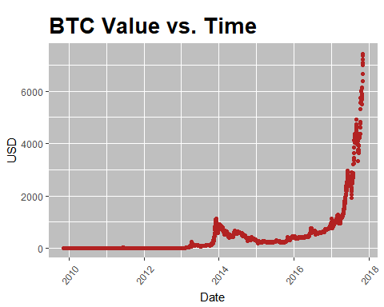 From the graph we can see that the value of bitcoin with respect to dollar has increased exponentially.

## Correlation between variables

BTC<-na.omit(BTC)  
library(corrplot)

## corrplot 0.84 loaded

cor <- cor(BTC[,2:12])  
#corrplot  
corrplot(cor, method = "pie")

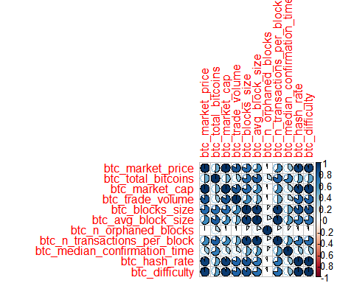

#Bitcoin date vs market price  
plot(BTC$Date, BTC$btc_market_price)

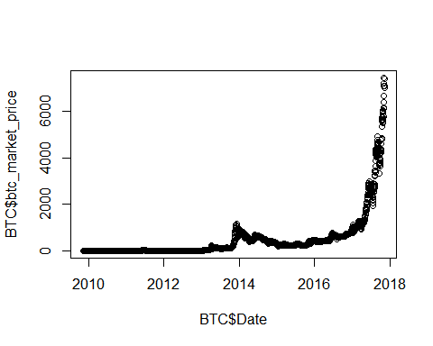

#Bitcoin market price vs market cap  
mod<-lm(btc_market_price~btc_market_cap, data=BTC)  
mod1<-lm(btc_market_price~btc_estimated_transaction_volume_usd, data=BTC)  
summary(mod)

##   
## Call:  
## lm(formula = btc_market_price ~ btc_market_cap, data = BTC)  
##   
## Residuals:  
## Min 1Q Median 3Q Max   
## -105.646 -29.737 -8.419 3.797 280.916   
##   
## Coefficients:  
## Estimate Std. Error t value Pr(>|t|)   
## (Intercept) 3.208e+01 9.563e-01 33.55 <2e-16 ***  
## btc_market_cap 6.029e-08 5.569e-11 1082.63 <2e-16 ***  
## ---  
## Signif. codes: 0 '***' 0.001 '**' 0.01 '*' 0.05 '.' 0.1 ' ' 1  
##   
## Residual standard error: 46.59 on 2897 degrees of freedom  
## Multiple R-squared: 0.9975, Adjusted R-squared: 0.9975   
## F-statistic: 1.172e+06 on 1 and 2897 DF, p-value: < 2.2e-16

summary(mod1)

##   
## Call:  
## lm(formula = btc_market_price ~ btc_estimated_transaction_volume_usd,   
## data = BTC)  
##   
## Residuals:  
## Min 1Q Median 3Q Max   
## -3630.5 -63.4 -59.9 20.9 3372.0   
##   
## Coefficients:  
## Estimate Std. Error t value Pr(>|t|)  
## (Intercept) 6.336e+01 6.940e+00 9.131 <2e-16  
## btc_estimated_transaction_volume_usd 3.629e-06 2.607e-08 139.193 <2e-16  
##   
## (Intercept) ***  
## btc_estimated_transaction_volume_usd ***  
## ---  
## Signif. codes: 0 '***' 0.001 '**' 0.01 '*' 0.05 '.' 0.1 ' ' 1  
##   
## Residual standard error: 338.4 on 2897 degrees of freedom  
## Multiple R-squared: 0.8699, Adjusted R-squared: 0.8699   
## F-statistic: 1.937e+04 on 1 and 2897 DF, p-value: < 2.2e-16

plot(BTC$btc_market_price,BTC$btc_market_cap)

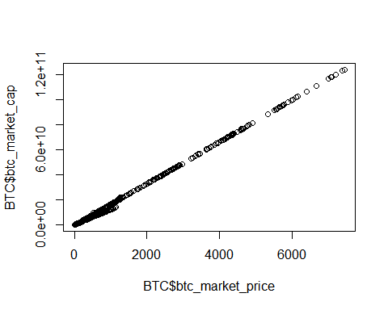

plot(BTC$btc_market_price,BTC$btc_estimated_transaction_volume_usd)

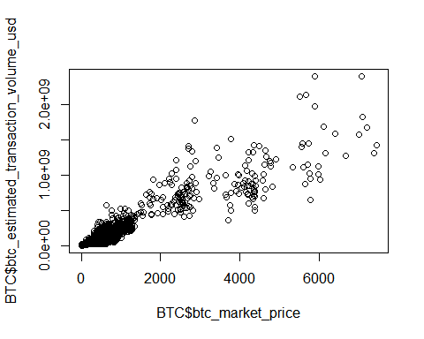

## Market Price Vs Miners Revenue

ggplot(BTC2, aes(BTC2$btc_miners_revenue/1000000, BTC2$btc_market_price)) +   
 geom_point(color="firebrick") +  
 ggtitle('BTC Miners Revenue vs. Market Price') +  
 theme(plot.title = element_text(size=19.5, face="bold",   
 margin = margin(10, 0, 10, 0)))+  
 labs(x="Miners Revenue MM (USD)", y="Market Price (USD)")+  
 theme(axis.text.x=element_text(angle=90, vjust=0.5)) +  
 theme(panel.background = element_rect(fill = 'grey75'))+  
 stat_smooth(method = "lm", formula = y ~ poly(x,2), col = "yellow")

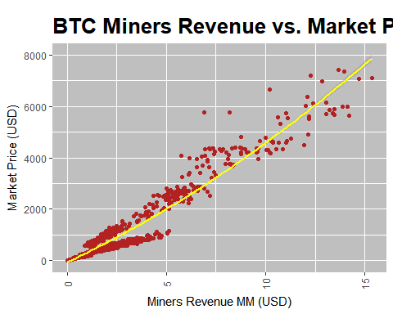 ##Difficulty vs. Market Price

ggplot(BTC2, aes(BTC2$btc_difficulty/1000000000, BTC2$btc_market_price)) +   
 geom_point(color="firebrick") +  
 ggtitle('BTC Difficulty vs. Market Price') +  
 theme(plot.title = element_text(size=19.5, face="bold",   
 margin = margin(10, 0, 10, 0)))+  
 labs(x="Block Find Difficulty (Billions)", y="Market Price (USD)")+  
 theme(axis.text.x=element_text(angle=90, vjust=0.5)) +  
 theme(panel.background = element_rect(fill = 'grey75'))+  
 stat_smooth(method = "lm", formula = y ~ poly(x,2), col = "yellow")

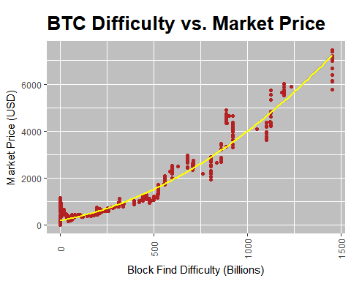 ##Hash Rate vs. Market Price

ggplot(BTC2, aes(BTC2$btc_hash_rate/1000000, BTC2$btc_market_price)) +   
 geom_point(color="firebrick") +  
 ggtitle('BTC Hash Rate vs. Market Price') +  
 theme(plot.title = element_text(size=19.5, face="bold",   
 margin = margin(10, 0, 10, 0)))+  
 labs(x="Hash Rate (Millions)", y="Market Price (USD)")+  
 theme(axis.text.x=element_text(angle=90, vjust=0.5)) +  
 theme(panel.background = element_rect(fill = 'grey75'))+  
 stat_smooth(method = "lm", formula = y ~ poly(x,2), col = "yellow")

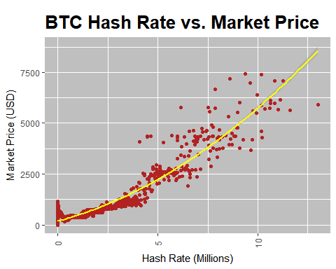 ##Loading Library’s

library(knitr)  
library(pander)  
library(tidyverse)

## -- Attaching packages ---------------------------------------------------------------- tidyverse 1.2.1 --

## v tibble 1.4.1 v purrr 0.2.4  
## v tidyr 0.7.2 v dplyr 0.7.4  
## v readr 1.1.1 v stringr 1.2.0  
## v tibble 1.4.1 v forcats 0.2.0

## -- Conflicts ------------------------------------------------------------------- tidyverse_conflicts() --  
## x ggplot2::%+%() masks psych::%+%()  
## x ggplot2::alpha() masks psych::alpha()  
## x dplyr::filter() masks stats::filter()  
## x dplyr::lag() masks stats::lag()

library(broom)  
library(DataCombine)  
library(caret)

## Loading required package: lattice

##   
## Attaching package: 'caret'

## The following object is masked from 'package:purrr':  
##   
## lift

## Summary of Regression Model

lmfit1<-lm(BTC2$btc_market_price~BTC2$btc_market_cap)  
panderOptions("digits", 2)  
pander(lmfit1, caption = "Linear Model: Market Price ~ Market Capitalization")

Linear Model: Market Price ~ Market Capitalization

|  |  |  |  |  |
| --- | --- | --- | --- | --- |
|  | Estimate | Std. Error | t value | Pr(>|t|) |
| **(Intercept)** | 46 | 1.2 | 38 | 3.4e-241 |
| **BTC2$btc_market_cap** | 6e-08 | 6.2e-11 | 973 | 0 |

R1=summary(lmfit1)$r.squared  
cat("R-Squared = ", R1)

## R-Squared = 0.9977156

Market Capitalization is signficant to Market Price.

## Residuals

plot(lmfit1, pch=16, which=1)

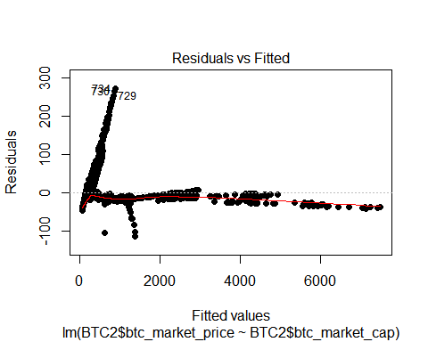 ##Estimated USD Transaction Volume vs. Market Price

ggplot(BTC2, aes(BTC2$btc_estimated_transaction_volume_usd/1000000, BTC2$btc_market_price)) +   
 geom_point(color="red") +  
 ggtitle('BTC Transaction Volume vs. Market Price') +  
 theme(plot.title = element_text(size=19.5, face="bold",   
 margin = margin(10, 0, 10, 0)))+  
 labs(x="Transaction Volume MM (USD)", y="Market Price (USD)")+  
 theme(axis.text.x=element_text(angle=90, vjust=0.5)) +  
 theme(panel.background = element_rect(fill = 'grey75'))+  
 stat_smooth(method = "lm", formula = y ~ poly(x,2), col = "white")

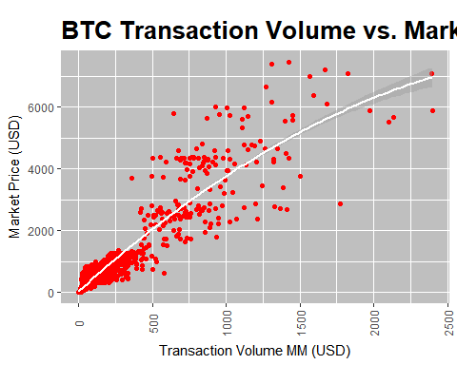

lmfit2<-lm(BTC2$btc_market_price~poly(BTC2$btc_estimated_transaction_volume_usd,2))  
panderOptions("digits", 2)  
pander(lmfit2, caption = "Linear Model: Market Price ~ Estimated Transaction Volume (USD) Squared")

Linear Model: Market Price ~ Estimated Transaction Volume (USD) Squared (continued below)

|  |  |  |  |  |
| --- | --- | --- | --- | --- |
|  | Estimate | | Std. Error | |
| **(Intercept)** | 635 | | 8.1 | |
| **poly(BTC2$btc_estimated_transaction_volume_usd, 2)1** | 44731 | | 377 | |
| **poly(BTC2$btc_estimated_transaction_volume_usd, 2)2** | -4514 | | 377 | |
|  | | t value | | Pr(>|t|) | |
| **(Intercept)** | | 78 | | 0 | |
| **poly(BTC2$btc_estimated_transaction_volume_usd, 2)1** | | 119 | | 0 | |
| **poly(BTC2$btc_estimated_transaction_volume_usd, 2)2** | | -12 | | 4.9e-32 | |

R2=summary(lmfit2)$r.squared  
cat("R-Squared = ", R2)

## R-Squared = 0.8678923

Transaction volume is significant to market price ##Residuals

plot(lmfit2, pch=16, which=1)

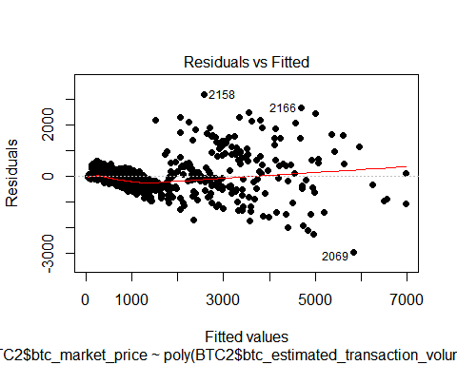 the price increases the variability increases ##Regression model

lmfit7 <- lm(BTC2$btc_market_price ~ poly(BTC2$btc_estimated_transaction_volume_usd, 2) + poly(BTC2$btc_miners_revenue, degree=2))  
  
panderOptions("digits", 2)  
pander(lmfit7, caption = "Linear Model: Market Price ~ Miners Revenue Squared + Count of Transactions Squared")

Linear Model: Market Price ~ Miners Revenue Squared + Count of Transactions Squared (continued below)

|  |  |  |  |  |
| --- | --- | --- | --- | --- |
|  | Estimate | | Std. Error | |
| **(Intercept)** | 635 | | 4.4 | |
| **poly(BTC2$btc_estimated_transaction_volume_usd, 2)1** | 16300 | | 462 | |
| **poly(BTC2$btc_estimated_transaction_volume_usd, 2)2** | -6159 | | 269 | |
| **poly(BTC2$btc_miners_revenue, degree = 2)1** | 31297 | | 463 | |
| **poly(BTC2$btc_miners_revenue, degree = 2)2** | 6864 | | 268 | |
|  | | t value | | Pr(>|t|) | |
| **(Intercept)** | | 143 | | 0 | |
| **poly(BTC2$btc_estimated_transaction_volume_usd, 2)1** | | 35 | | 2e-215 | |
| **poly(BTC2$btc_estimated_transaction_volume_usd, 2)2** | | -23 | | 4.7e-104 | |
| **poly(BTC2$btc_miners_revenue, degree = 2)1** | | 68 | | 0 | |
| **poly(BTC2$btc_miners_revenue, degree = 2)2** | | 26 | | 2.9e-126 | |

R7=summary(lmfit7)$r.squared  
cat("R-Squared = ", R7)

## R-Squared = 0.9604765

## Percentage Change

BTC<-mutate(BTC, pChange=(BTC$btc_market_price-lag(BTC$btc_market_price))/lag(BTC$btc_market_price)*100) #Add column for percentage of change  
  
ggplot(BTC, aes(BTC$Date, BTC$pChange)) +   
 geom_point(color="firebrick") +  
 ggtitle('BTC Percent Change vs. Time') +  
 theme(plot.title = element_text(size=20, face="bold",   
 margin = margin(10, 0, 10, 0)))+  
 labs(x="Date", y="Pct. Change")+  
 theme(axis.text.x=element_text(angle=50, vjust=0.5)) +  
 theme(panel.background = element_rect(fill = 'grey75'))

## Warning: Removed 280 rows containing missing values (geom_point).

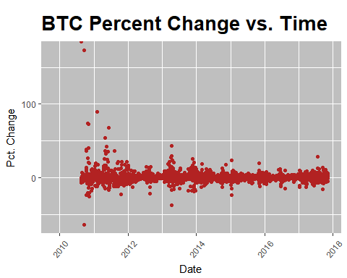 ##Mutate Data in Percent Change

library(zoo)

##   
## Attaching package: 'zoo'

## The following objects are masked from 'package:base':  
##   
## as.Date, as.Date.numeric

BTC2$AVGtransactionvolume<-BTC2$btc_estimated_transaction_volume_usd  
BTC2$AVGminersrevenue<-BTC2$btc_miners_revenue  
BTC2$AVGmarketcap<-BTC2$btc_market_cap  
BTC2$pctChange<-BTC2$btc_market_price  
BTC2$AVGtotalbitcoins<-BTC2$btc_total_bitcoins  
  
BTC11<- subset(BTC2, BTC2$AVGminersrevenue>0)  
BTC11<-mutate(BTC11, pctChange=(BTC2$btc_market_price-lag(BTC2$btc_market_price))/lag(BTC2$btc_market_price)*100)  
BTC11<-mutate(BTC11, AVGtransactionvolume=(BTC2$AVGtransactionvolume-lag(BTC2$AVGtransactionvolume))/lag(BTC2$AVGtransactionvolume)*100)  
BTC11<-mutate(BTC11, AVGminersrevenue=(BTC2$AVGminersrevenue-lag(BTC2$AVGminersrevenue))/lag(BTC2$AVGminersrevenue)*100)  
BTC11<-mutate(BTC11, AVGmarketcap=(BTC2$AVGmarketcap-lag(BTC2$AVGmarketcap))/lag(BTC2$AVGmarketcap)*100)  
BTC11<-mutate(BTC11, AVGtotalbitcoins=(BTC2$AVGtotalbitcoins-lag(BTC2$AVGtotalbitcoins))/lag(BTC2$AVGtotalbitcoins)*100)  
  
ggplot(BTC2, aes(BTC11$Date, BTC11$pctChange)) +   
 geom_point(color="firebrick") +  
 ggtitle('BTC Percent Change vs. Time') +  
 theme(plot.title = element_text(size=20, face="bold",   
 margin = margin(10, 0, 10, 0)))+  
 labs(x="Date", y="Pct. Change")+  
 theme(axis.text.x=element_text(angle=50, vjust=0.5)) +  
 theme(panel.background = element_rect(fill = 'grey75'))

## Warning: Removed 1 rows containing missing values (geom_point).

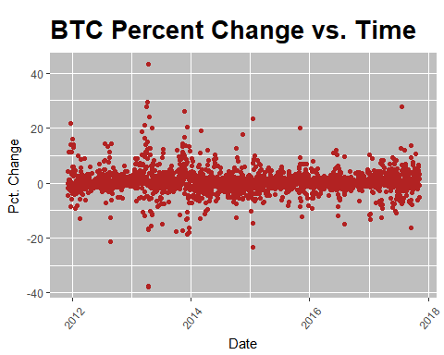 ##Correlation Analysis of Transformed Variables

cor2 <- cor(BTC11[c(2:2167),c(26:30)]) #selecting variables to include in correlation analysis  
  
colnames(cor2) <- c("% Change Transx Volume", "% Change Miner Rev.","% Change Market Cap", "% Change Market Price","Change Total Coins")  
rownames(cor2) <- c("% Change Transx Volume", "% Change Miner Rev.","% Change Market Cap","% Change Market Price", "Change Total Coins")  
  
corrplot(cor2, method = "circle", tl.srt = 50, tl.col = "black", tl.cex = 0.6, title = "Correlation of Variables", mar=c(0,0,1,0))

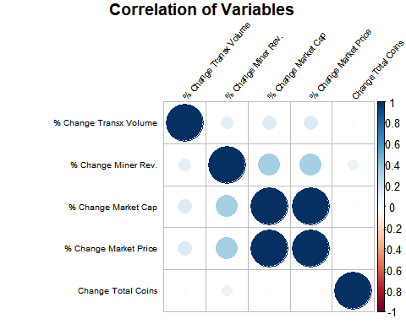 ##What is the significance of these variables to the percent change in market price?

lmfit8 <- lm(pctChange ~ AVGmarketcap+AVGtotalbitcoins, BTC11)  
  
panderOptions("digits", 2)  
pander(lmfit8, caption = "Linear Model: Market Price Change ~ Market Cap Change + Total Coins Change")

Linear Model: Market Price Change ~ Market Cap Change + Total Coins Change ##Train Model and Test Percent Change ##Creating the training subset and test subset

|  |  |  |  |  |
| --- | --- | --- | --- | --- |
|  | Estimate | Std. Error | t value | Pr(>|t|) |
| **(Intercept)** | 0.0036 | 0.02 | 0.18 | 0.86 |
| **AVGmarketcap** | 0.99 | 0.0025 | 398 | 0 |
| **AVGtotalbitcoins** | -1 | 0.48 | -2.1 | 0.037 |

set.seed(1)  
train2.index<-sample(1:nrow(BTC11),0.90*nrow(BTC11), replace=FALSE)  
train2 <- BTC11[train2.index, ]  
test2 <- BTC11[-train2.index,]

## Training and testing

lmtrain2 <- lm(pctChange~AVGmarketcap+AVGtotalbitcoins, train2)  
test2$p1 <- predict(lmtrain2,test2)  
error=mean(abs(test2$p1-test2$pctChange))  
cat("Mean Error = ", error)

## Mean Error = 0.06610463

Very small amount of error.

ggplot(test2, aes(test2$Date)) +   
 geom_point(aes(y=test2$pctChange),color="Firebrick") +  
 geom_line(aes(y=test2$p1), color="Blue")+  
 ggtitle('') +  
 theme(plot.title = element_text(size=10, face="bold",   
 margin = margin(10, 0, 10, 0)))+  
 labs(x="Time", y="Percent Change in Value")+  
 theme(axis.text.x=element_text(angle=90, vjust=0.5)) +  
 theme(panel.background = element_rect(fill = 'grey75'))+  
 labs(title = paste("BTC Market Price % Change ~ BTC Market Cap % Change + Total Coins % Change",  
 "\n\nAdj R2 = ",signif(summary(lmtrain2)$adj.r.squared, 5),  
 " P =",signif(summary(lmtrain2)$coef[2,4], 2)))

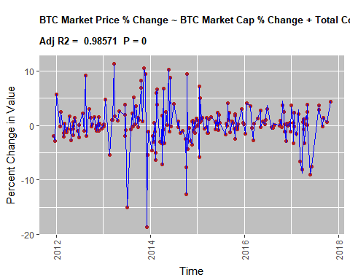

## Conclusion

It’s difficult to predict the price of bitcoin due to fluctuatuion in market Shown above, percent change in the value of Bitcoin is highly dependent to the percent change in market capitalization and percent change in total bitcoins in circulation.